ITWS-1100

08 February 2024

**College Exam Hub Proposal**

Felipe Alves, Joseph Fodera, Alex Kuang

*Intended Purpose:* To provide a streamlined, up-to-date, and easily accessible/navigable way to go about obtaining back exams from previous years. Would do this by curating a database of exams that would be retrievable/able to be updated by users of this web application.

*Target Audience:* This web application would be centered around, but not limited to, college students at Universities that administer exams. While the website would not be locked to people who do not fall in that category, contributions to the database would be.

*Distinguishing Features:*  This web application will be constantly updated and will utilize a database that its users can add and remove back exams from. Users will be able to add back exams to the web app, rate them based on relevance, and report them if they are not a back exam, or if they have been added to the wrong course. There will also be moderators that deal with these reports. Users will also be able to upload questions/comments related to said exam on an exam-specific discussion page where answers can be discussed.

*Inspiration and demand:* We wanted to make an organized hub where students can quickly find relevant back exams. As of now, finding back exams is fairly time-consuming due to there being no organized central hub dedicated to them, as well as the fact that many exams are outdated and not relevant to what is being taught in the courses the exams are for.

*IA:*

This hypothetical application would be heavily reliant on user contribution. As mentioned above, the main aspect/drawing feature of it is the fact that this exam database is constantly kept up to date, and that would primarily be done by the users. If fully developed, we would have a 'starter database' full of as many exams as we could gather given a user-driven database has to start somewhere. This 'version' of the application will be specific to RPI, built with the thought of expanding it to store data for any university in mind.

When a user navigates to College Exam Hub, they would arrive at a homepage defining the school (RPI), and some information about College Exam Hub. This is also where they can confirm their university email with the web app to be able to make contributions. If searching, they would then click on a 'find exams' button and be brought to a page in which they could search for their course by name/id. On this page, there would also be an 'upload your own' button which the user could click if they validated their email. This would take them to a page in which they would need to fill in some information about their upload and ultimately send in their exam.

If they choose to search, once they find their course they will be brought to the course landing page which will have a feed of uploaded exams. You can sort available exams by specific tags (ie 'Exam 1', 'Quiz 1', etc), by date, or uploaded/rating.

Once you find an exam that looks like the one you're searching for, you will click on that and be brought to a page for that specific upload. It would present you with upload-specific data like when it was uploaded, its current ratings, the option to report it as 'not an exam' or ‘for the wrong class’, and obviously the upload (exam) itself and the ability to download it. From there, if you validated your university email, you could leave your own rating/review or report it for not being an exam. There will be a page where you can see others’ reviews and a page for discussions regarding the exam’s problems, where users can leave questions and help each other out.

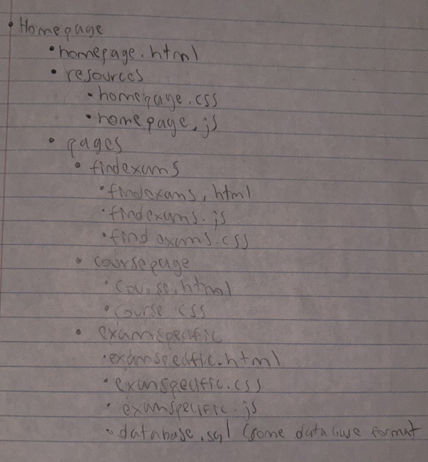

Primary/Secondary Areas of Focus (not final):

* Primary: Area 1- HTML, CSS and graphics for page layout and design
* Secondary: Area 5- putting real data into a database

*Project Future Assignments and layout as of now. We will all contribute heavily to each of these, just assigning 'heads'/leaders of each general area.*

* Producing an in depth description/reasoning while describing where it fits with existing applications.
  + all of us currently (proposal), primarily Alex in future
* Making a case for the value of application; what's distinguishing/new, what void is it filling?
  + Joe
* Developing a reasonably full IA exemplifying projects structure, navigation, interface, attributes.
  + Felipe
* Developing the demo/prototype.
  + No specific 'head' here, all of us leading this one.